22.46: a) (i) 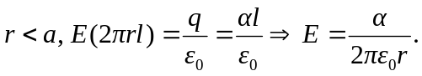
(ii) 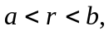 there is no net charge enclosed, so the electric field is zero.

(iii) 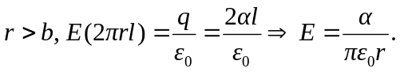
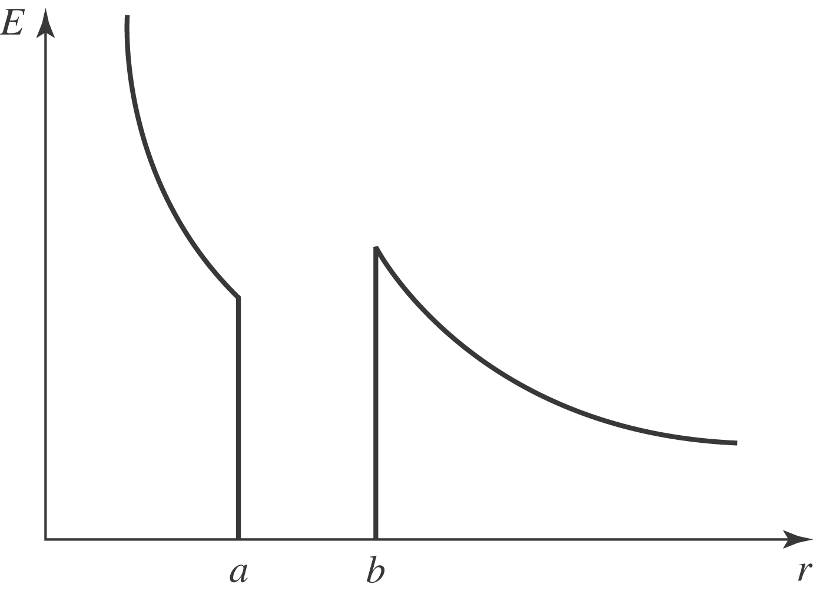

b) (i) Inner charge per unit length is (ii) Outer charge per length is 